Ex. No.: 8

Date:

**Joins – EquiJoin, InnerJoin, OuterJoin**

1. List the departments where the faculty members are working.

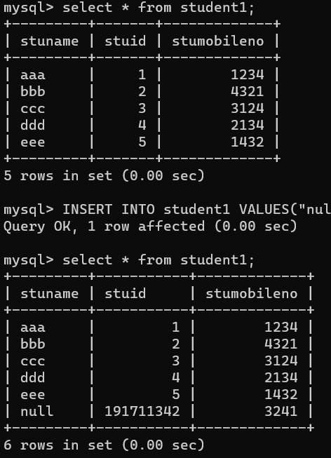

1. Update the value of student name whose register number is ‘191711342’

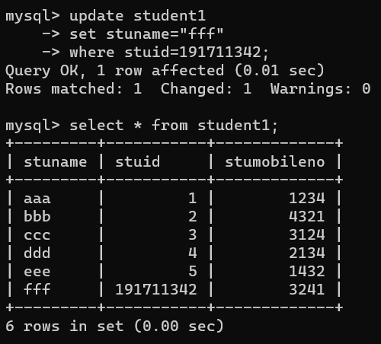

1. Delete the record in the table FACULTY, who resigned her job.

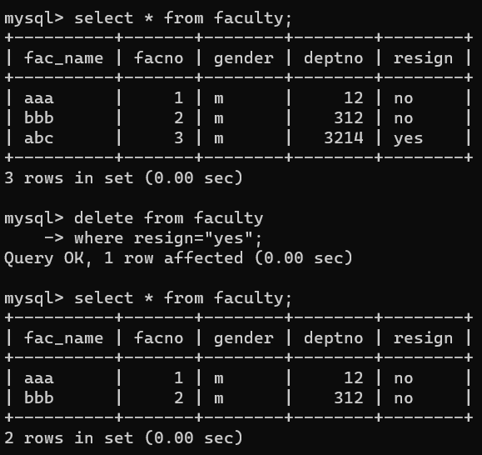

1. Remove all faculty who are having over 65 years

